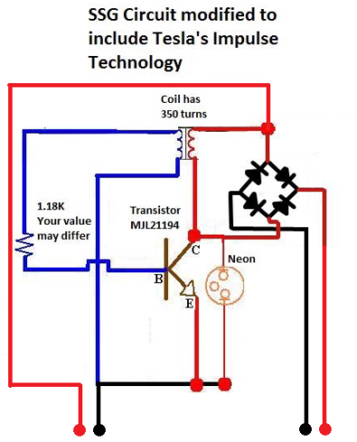

Output (Secondary)

Input (Primary)

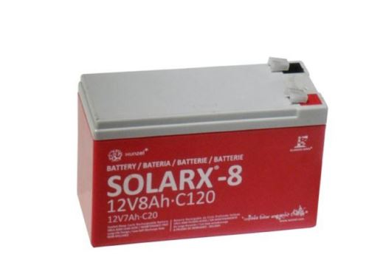

B4

B3

B2

B1

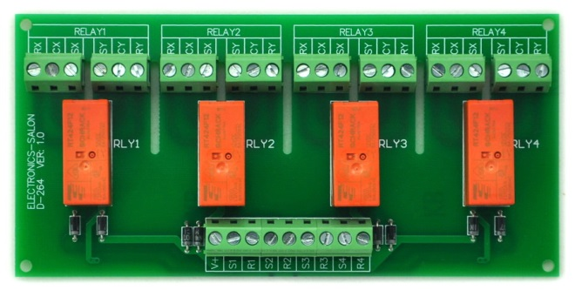

Isolation barrier

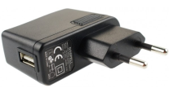

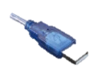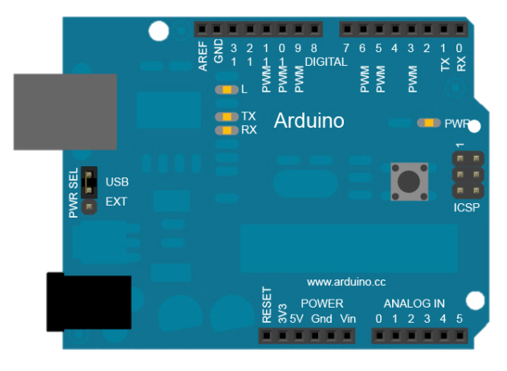



5V/1A USB Power Supply

For Arduino & Relays power

You need:

-Arduino UNO with this code:

(TODO)

- 1x latching 4x relay DPDT 8A 5V module.

Ebay: <http://www.ebay.es/itm/131232400622?ssPageName=STRK:MEWAX:IT&_trksid=p3984.m1423.l2649>

-Your Bedini monopole motor/energizer assembly and 4 batteries.